Controls:

P – Pausing/Unpausing the Scene

PAUSE – Pausing/Unpausing the Scene rotation

WASD – moving the camera

L – Locking/Unlocking the scene’s camera

TAB – Splitscreen

LEFT ARROW – Previous Scene

RIGHT ARROW – Next Scene

1/2/3 – Selecting Scenes

7 – Toggle Sobel post processing effect

8 – Toggle contrast post processing effect

R – Reset Scene to the start

C – Show Controls on screen

F – Show features on screen

**Youtube Link:** <https://www.youtube.com/watch?v=r5ulN4dQ2RA>

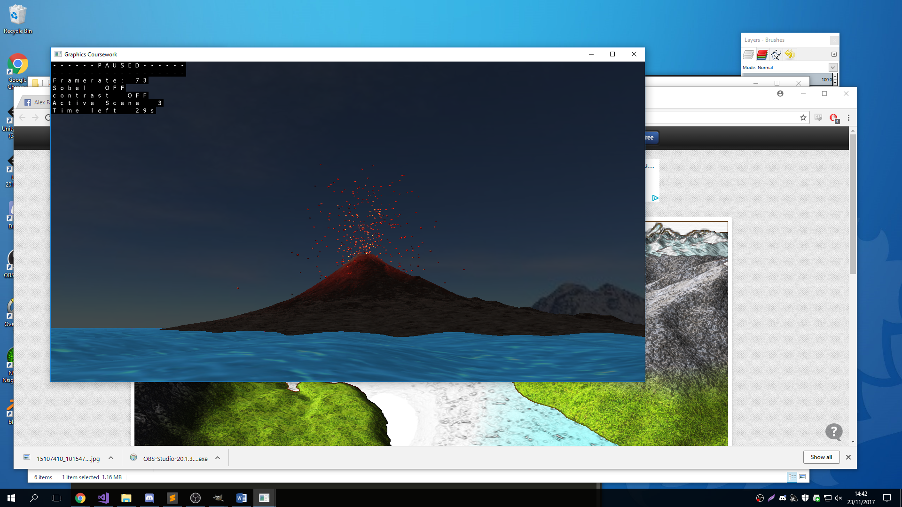

Volcano Scene Features:

- Tessellation of a plane of 16x16 quads ("patches"). Each quad gets tessellated to 64x64 quads. A height map (2D grayscale texture) is read in and applied to this using a scaling factor which allows the terrain to grow over time.

- Tessellation of the water. This works similarly to the terrain, however it takes 32x32 quads ("patches") and applies two sine waves to the height in order to simulate the wave effect. One of these is diagonal and one along the x axis.

- Particle effects: Lava particles emitted from the volcano. The particle emitter spawns then within the crater of the volcano and moves up as the volcano grows. The particles get given a random (with constraints) velocity and have a constant downwards acceleration to simulate gravity.

- Deferred Rendering: Each lava particle emitted from the volcano has its own light attached to it. This is done by spawning a new light for every particle in every frame and then deleting it after drawing (there are more efficient ways of doing this but it gets quite complicated). There is a final light which lights up the scene slightly more rather than just the lava’s lights.

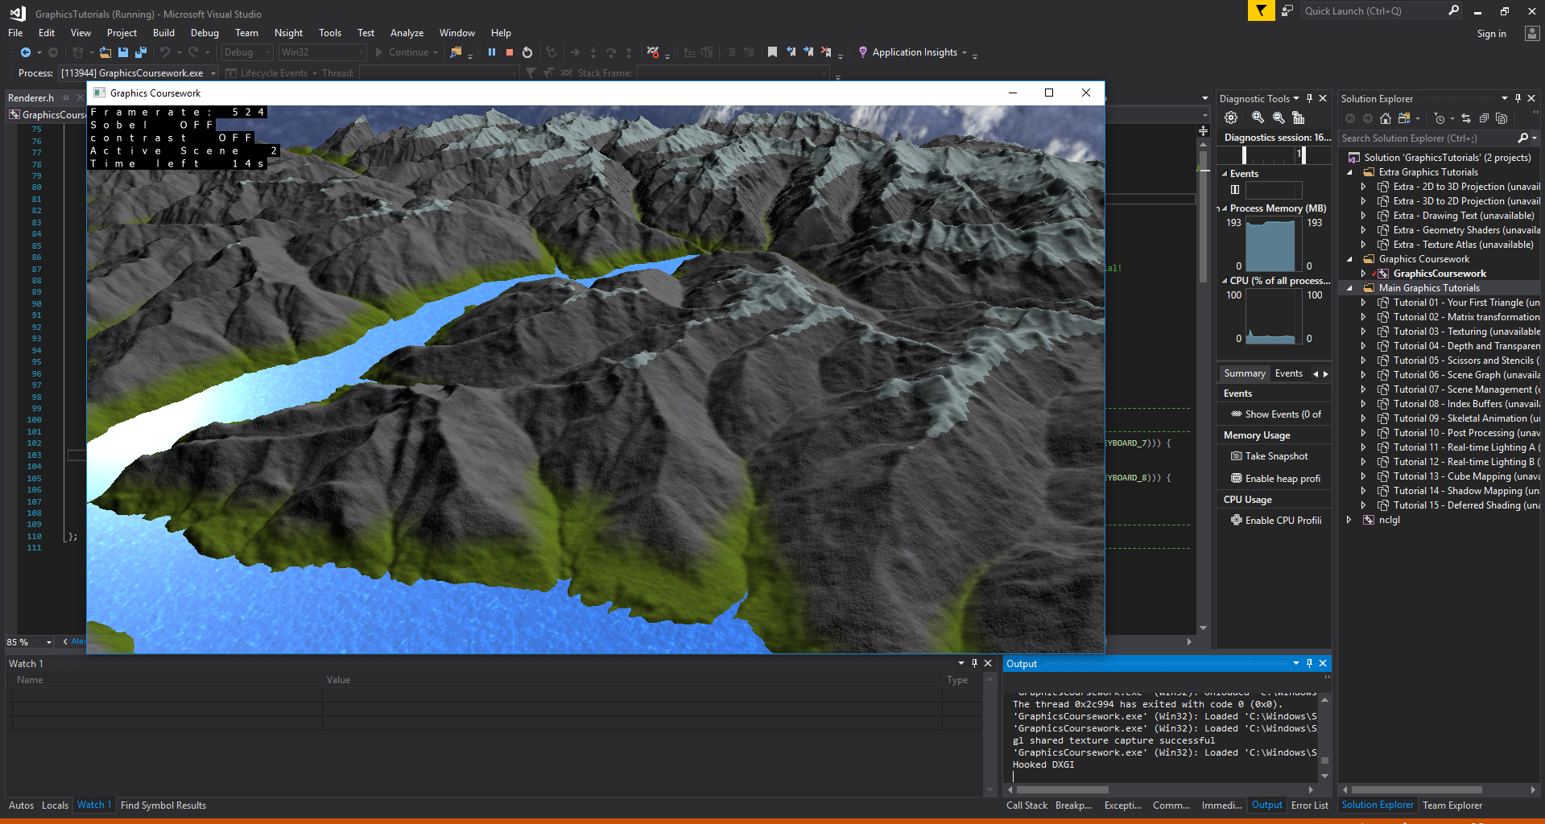

Mountain Scene Features:

- Height map generation using a given texture. It takes a texture which is 1080 by 1080 and builds the terrain according to that size. It basically works the same way as the height map from the tutorial but on a larger scale and with a custom height map.

- Basic Lighting with ambient, diffuse and specular lighting as well as reflection of the skybox in the water

- Environment mapping: Skybox and reflections in the water

- Texture blending: The texture on the terrain is determined by the y value of the terrain and will blend at the intersection of the two textures.

- Periodically changing textures: The snow height is determined on a periodic basis and changes according to this from very little snow (as shown in the scene) to the entire scene being white. This is done in the shader that takes a uniform “offset”. Furthermore so that the snowline is not straight this is offset using two sine curves.

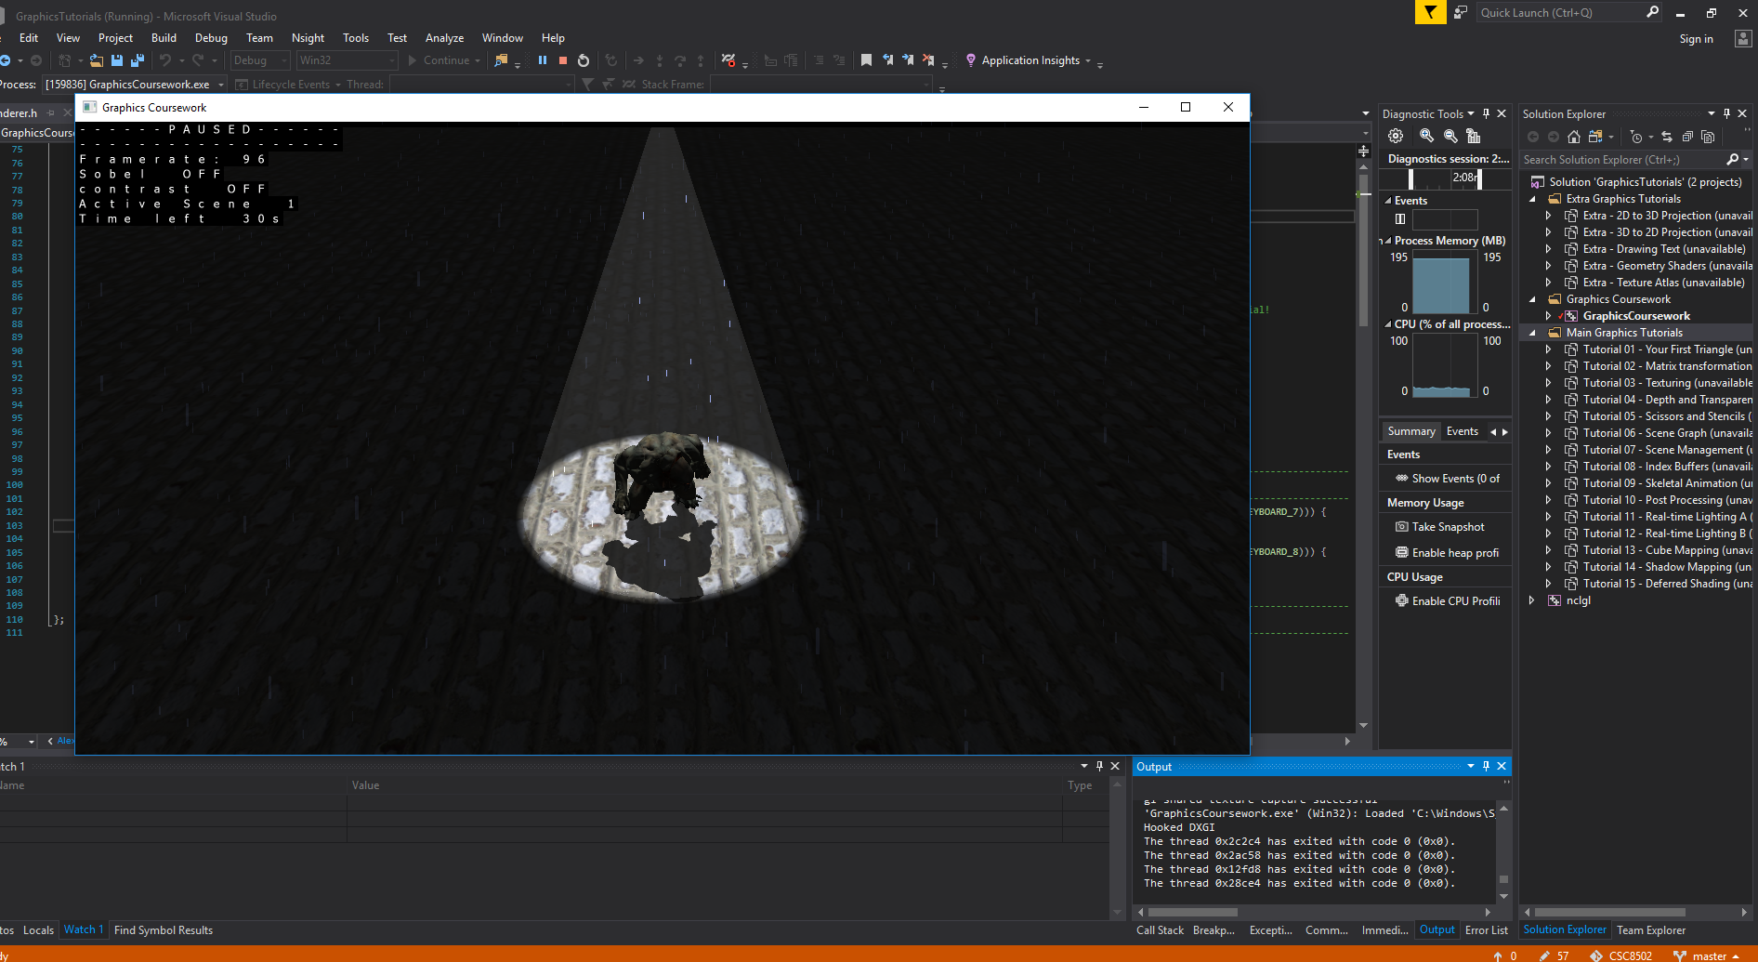

Shadow/Rain Scene Features:

- Rain particle effects: spawned in a square at a height above the light. All particles have the same velocity falling straight down and get deleted when they hit the floor.

- Skeletal Animation: The hellknight is doing his idle animation up to a certain point at which it switches to the walking animation and walks off, then switches back to the idle animation when he stops.

- Advanced lighting: A spotlight which only lights up the area with a certain field of view angle. The shader for the floor also includes a calculation whether or not the line of sight intersects the “cone of light” of the spotlight. If it does it will add a small amount of the light’s colour to the fragment. This is not done to the hell knight so that he does not get a more faded brighter look.

- Real time shadows of the hellknight on the floor and himself. A shadow map is created from the light looking downwards to cast shadows onto the floor.

- Scene Management (using Scene Nodes)

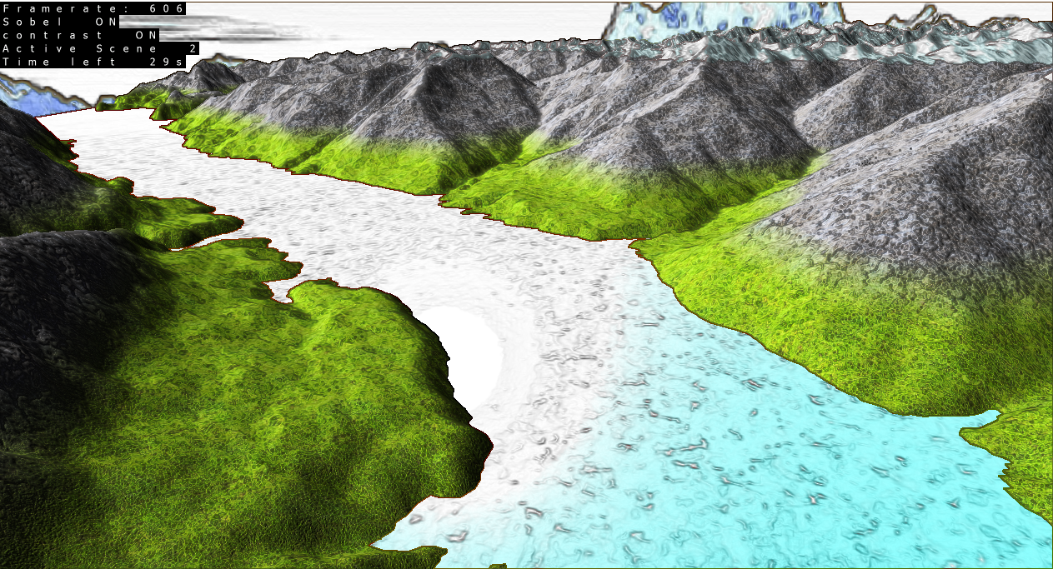

Post Processing effects:

* Sobel edge detection: effect will draw black lines onto edges that it detects to give it the “borderlandsy” look.
* Brightness/Contrast: This effect takes in a given brightness and contrast value and applies this to all colours/fragments in the scene.
* They can be combined so that they are both turned on (as shown in the screenshot)

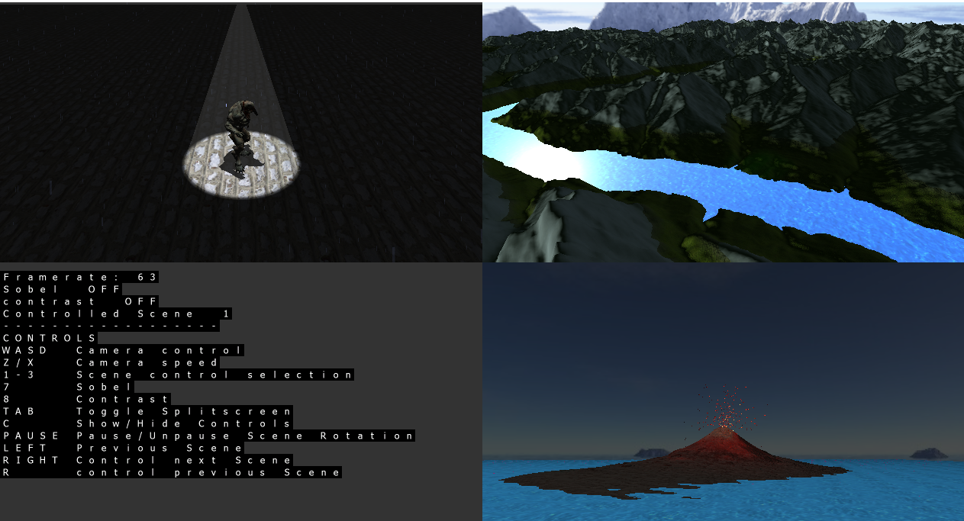

Split screen Effect:

* Runs all scenes at the same time in split screen
* Can choose which scene’s camera to control
* Can press tab to get back to single screen view